 | 

Faculty of Technology and Engineering
Chandubhai S. Patel Institute of Technology (CSPIT) Department of Computer Science & Engineering
Date: / /
Laboratory Manul

Academic Year | : | 2026-27 | Semester | : | 3rd
Course code | : | ITUE203 | Course name | : | WEB DEVELOPMENT FRAMEWORKS

Practical – 1
PROBLEM STATEMENT :
Initiate the semester-long StudentHub portal by identifying the problem scope, user roles, key modules, navigation flow, and minimum 10 pages.
Create a sitemap, low-fidelity wireframe, project folder structure,
README file, and GitHub repository.

Objective :
To initiate the development of a semester-long StudentHub Portal by analyzing the problem requirements, identifying the target users and their roles, designing the key functional modules, creating a clear navigation flow, and planning a minimum 10-page website. The project also aims to establish a structured development workflow by preparing a sitemap, low-fidelity wireframes, project folder structure, README documentation, and a GitHub repository for version control and collaborative development.

Code :

Sitemap

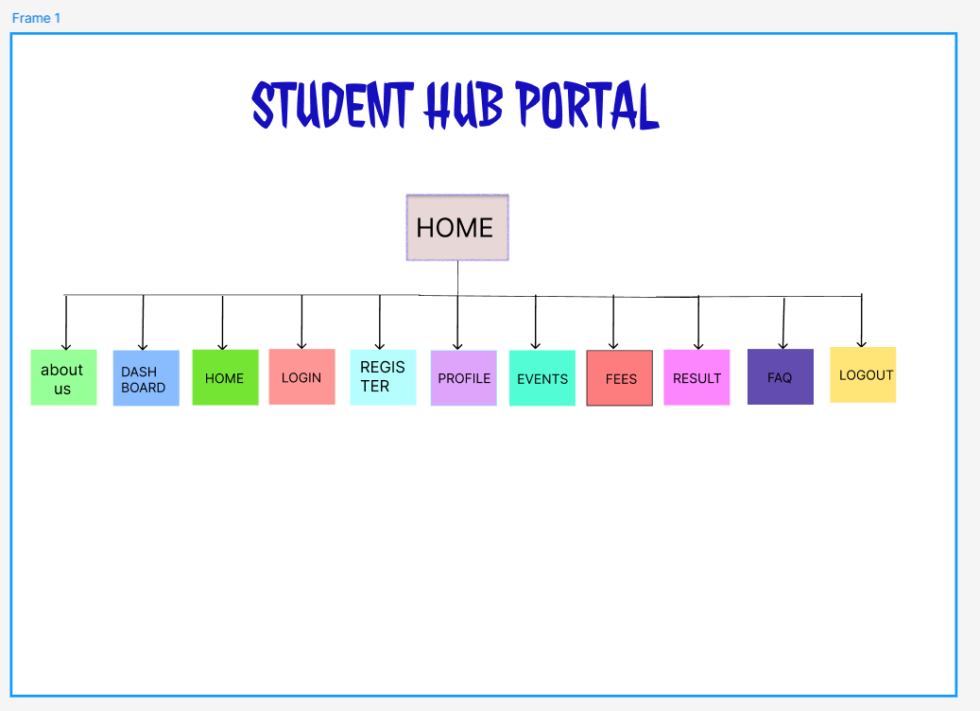

Home.html

WireFrame

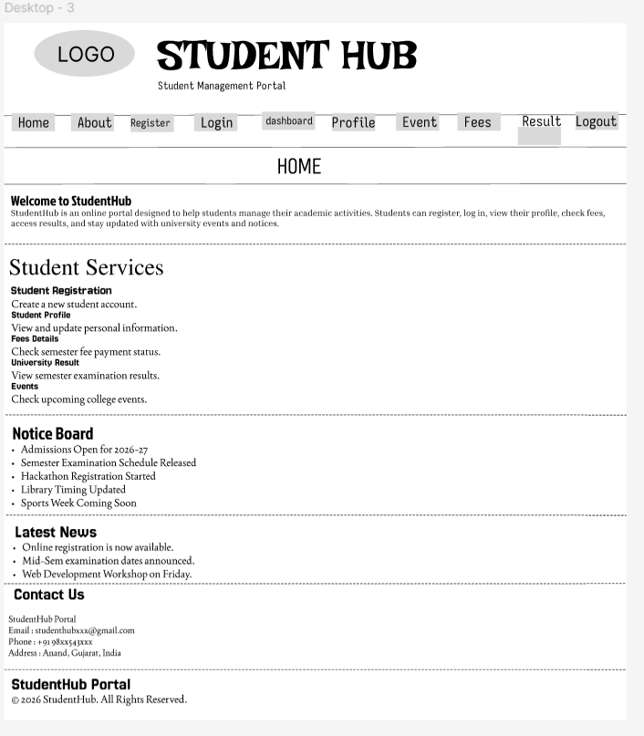

<!DOCTYPE html>
<html lang="en">

<head>
<meta charset="UTF-8">
<meta name="viewport" content="width=device-width, initial-scale=1.0">
<title>StudentHub | Home</title>
</head>

<body>

<header>

<table width="100%">
<tr>
<td width="15%">
<img src="studenthubLOGO.jpg" alt="StudentHub Logo" width="100">
</td>

<td>
<h1>StudentHub</h1>
<h3>Student Management Portal</h3>
</td>
</tr>
</table>

<hr>

<nav>
<a href="home.html">Home</a> |
<a href="about.html">About</a> |
<a href="register.html">Register</a> |
<a href="login.html">Login</a> |
<a href="dashboard.html">Dashboard</a> |
<a href="profile.html">Profile</a> |
<a href="event.html">Events</a> |
<a href="fees.html">Fees</a> |
<a href="result.html">Result</a> |
<a href="logout.html">Logout</a>
</nav>

<hr>

</header>

<main>

<section>

<h2>Welcome to StudentHub</h2>

<p>
StudentHub is an online portal designed to help students manage
their academic activities. Students can register, log in,
view their profile, check fees, access results, and stay updated
with university events and notices.
</p>

</section>

<hr>

<section>

<h2>Student Services</h2>

<article>
<h3>Student Registration</h3>
<p>Create a new student account.</p>
</article>

<article>
<h3>Student Profile</h3>
<p>View and update personal information.</p>
</article>

<article>
<h3>Fees Details</h3>
<p>Check semester fee payment status.</p>
</article>

<article>
<h3>University Result</h3>
<p>View semester examination results.</p>
</article>

<article>
<h3>Events</h3>
<p>Check upcoming college events.</p>
</article>

</section>

<aside>

<h2>Notice Board</h2>

<ul>
<li>Admissions Open for 2026-27</li>
<li>Semester Examination Schedule Released</li>
<li>Hackathon Registration Started</li>
<li>Library Timing Updated</li>
<li>Sports Week Coming Soon</li>
</ul>

</aside>

<hr>

<section>

<h2>Latest News</h2>

<ul>
<li>Online registration is now available.</li>
<li>Mid-Sem examination dates announced.</li>
<li>Web Development Workshop on Friday.</li>
</ul>

</section>

<hr>

<section>

<h2>Contact Us</h2>

<address>
StudentHub Portal<br><br>

Email : studenthubxxx@gmail.com<br><br>

Phone : +91 98xx543xxx<br><br>

Address : Anand, Gujarat, India
</address>

</section>

</main>

<hr>

<footer>

<p><strong>StudentHub Portal</strong></p>

<p>&copy; 2026 StudentHub. All Rights Reserved.</p>

</footer>

</body>

</html>

About.html

WireFrame

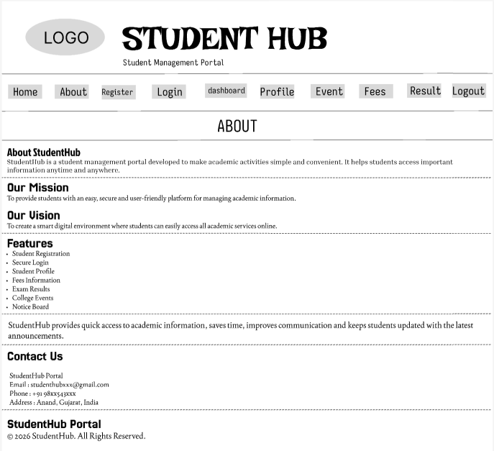

<!DOCTYPE html>
<html lang="en">

<head>
<meta charset="UTF-8">
<meta name="viewport" content="width=device-width, initial-scale=1.0">
<title>StudentHub | About</title>
</head>

<body>

<header>

<table width="100%">
<tr>
<td width="15%">
<img src="studenthubLOGO.jpg" alt="StudentHub Logo" width="100">
</td>

<td>
<h1>StudentHub</h1>
<h3>Student Management Portal</h3>
</td>
</tr>
</table>

<hr>

<nav>
<a href="home.html">Home</a> |
<a href="about.html">About</a> |
<a href="register.html">Register</a> |
<a href="login.html">Login</a> |
<a href="dashboard.html">Dashboard</a> |
<a href="profile.html">Profile</a> |
<a href="event.html">Events</a> |
<a href="fees.html">Fees</a> |
<a href="result.html">Result</a> |
<a href="logout.html">Logout</a>
</nav>

<hr>

</header>

<main>

<section>

<h2>About StudentHub</h2>

<p>
StudentHub is a student management portal developed to make
academic activities simple and convenient. It helps students
access important information anytime and anywhere.
</p>

</section>

<hr>

<section>

<h2>Our Mission</h2>

<p>
To provide students with an easy, secure and user-friendly
platform for managing academic information.
</p>

</section>

<hr>

<section>

<h2>Our Vision</h2>

<p>
To create a smart digital environment where students can
easily access all academic services online.
</p>

</section>

<hr>

<section>

<h2>Features</h2>

<ul>
<li>Student Registration</li>
<li>Secure Login</li>
<li>Student Profile</li>
<li>Fees Information</li>
<li>Exam Results</li>
<li>College Events</li>
<li>Notice Board</li>
</ul>

</section>

<hr>

<section>

<p>
StudentHub provides quick access to academic information,
saves time, improves communication and keeps students
updated with the latest announcements.
</p>

</section>

<hr>

<section>

<h2>Contact Information</h2>

<address>
StudentHub Portal<br><br>

Email : studenthubxxx@gmail.com<br><br>

Phone : +91 98xx543xxx<br><br>

Address : Anand, Gujarat, India
</address>

</section>

</main>

<hr>

<footer>

<p><strong>StudentHub Portal</strong></p>

<p>&copy; 2026 StudentHub. All Rights Reserved.</p>

</footer>

</body>

</html>

Dashboard.html

WireFrame

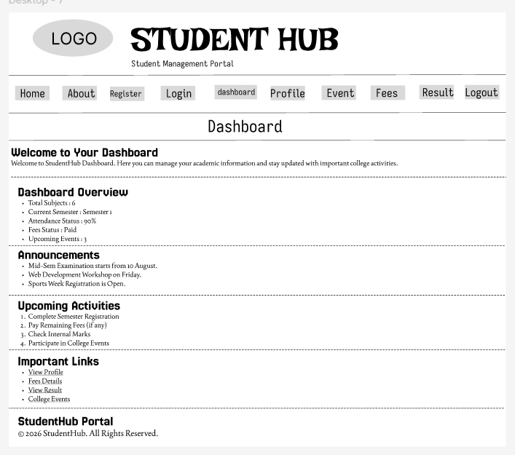

<!DOCTYPE html>
<html lang="en">

<head>
<meta charset="UTF-8">
<meta name="viewport" content="width=device-width, initial-scale=1.0">
<title>StudentHub | Dashboard</title>
</head>

<body>

<header>

<table width="100%">
<tr>

<td width="15%">
<img src="studenthubLOGO.jpg" alt="StudentHub Logo" width="100">
</td>

<td>
<h1>StudentHub</h1>
<h3>Student Dashboard</h3>
</td>

</tr>
</table>

<hr>

<nav>
<a href="home.html">Home</a> |
<a href="about.html">About</a> |
<a href="register.html">Register</a> |
<a href="login.html">Login</a> |
<a href="dashboard.html">Dashboard</a> |
<a href="profile.html">Profile</a> |
<a href="event.html">Events</a> |
<a href="fees.html">Fees</a> |
<a href="result.html">Result</a> |
<a href="logout.html">Logout</a>
</nav>

<hr>

</header>

<main>

<section>

<h2>Welcome to Your Dashboard</h2>

<p>
Welcome to StudentHub Dashboard. Here you can manage your academic information and stay updated with important college activities.
</p>

</section>

<hr>

<section>

<h2>Dashboard Overview</h2>

<ul>
<li>Total Subjects : 6</li>
<li>Current Semester : Semester 1</li>
<li>Attendance Status : 90%</li>
<li>Fees Status : Paid</li>
<li>Upcoming Events : 3</li>
</ul>

</section>

<hr>

<section>

<h2>Announcements</h2>

<ul>
<li>Mid-Sem Examination starts from 10 August.</li>
<li>Web Development Workshop on Friday.</li>
<li>Sports Week Registration is Open.</li>
</ul>

</section>

<hr>

<section>

<h2>Upcoming Activities</h2>

<ol>

<li>Complete Semester Registration</li>

<li>Pay Remaining Fees (if any)</li>

<li>Check Internal Marks</li>

<li>Participate in College Events</li>

</ol>

</section>

<hr>

<section>

<h2>Important Links</h2>

<ul>

<li><a href="profile.html">View Profile</a></li>

<li><a href="fees.html">Fees Details</a></li>

<li><a href="result.html">View Result</a></li>

<li><a href="event.html">College Events</a></li>

</ul>

</section>

</main>

<hr>

<footer>

<p><strong>StudentHub Portal</strong></p>

<p>&copy; 2026 StudentHub. All Rights Reserved.</p>

</footer>

</body>

</html>

Event.html

WireFrame

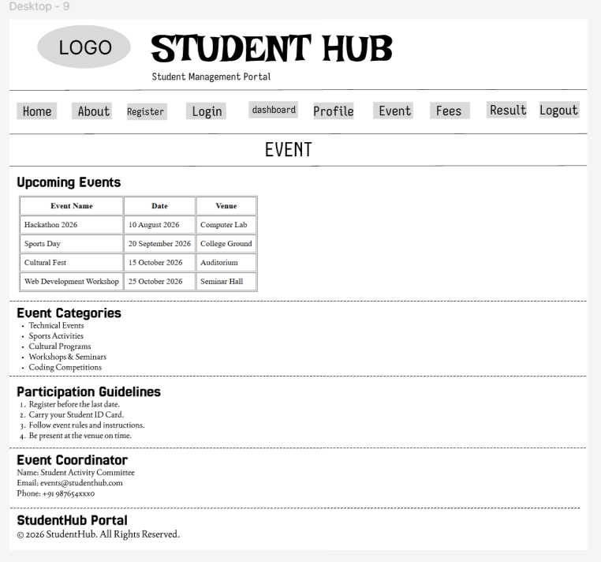

<!DOCTYPE html>
<html lang="en">

<head>
<meta charset="UTF-8">
<meta name="viewport" content="width=device-width, initial-scale=1.0">
<title>StudentHub | Events</title>
</head>

<body>

<header>

<table width="100%">
<tr>

<td width="15%">
<img src="studenthubLOGO.jpg" alt="StudentHub Logo" width="100">
</td>

<td>
<h1>StudentHub</h1>
<h3>College Events</h3>
</td>

</tr>
</table>

<hr>

<nav>
<a href="home.html">Home</a> |
<a href="about.html">About</a> |
<a href="register.html">Register</a> |
<a href="login.html">Login</a> |
<a href="dashboard.html">Dashboard</a> |
<a href="profile.html">Profile</a> |
<a href="event.html">Events</a> |
<a href="fees.html">Fees</a> |
<a href="result.html">Result</a> |
<a href="logout.html">Logout</a>
</nav>
<hr>

</header>

<main>

<section>

<h2>Upcoming Events</h2>

<table border="1" cellpadding="8">

<tr>
<th>Event Name</th>
<th>Date</th>
<th>Venue</th>
</tr>

<tr>
<td>Hackathon 2026</td>
<td>10 August 2026</td>
<td>Computer Lab</td>
</tr>

<tr>
<td>Sports Day</td>
<td>20 September 2026</td>
<td>College Ground</td>
</tr>

<tr>
<td>Cultural Fest</td>
<td>15 October 2026</td>
<td>Auditorium</td>
</tr>

<tr>
<td>Web Development Workshop</td>
<td>25 October 2026</td>
<td>Seminar Hall</td>
</tr>

</table>

</section>

<hr>

<section>

<h2>Event Categories</h2>

<ul>

<li>Technical Events</li>

<li>Sports Activities</li>

<li>Cultural Programs</li>

<li>Workshops & Seminars</li>

<li>Coding Competitions</li>

</ul>

</section>

<hr>

<section>

<h2>Participation Guidelines</h2>

<ol>

<li>Register before the last date.</li>

<li>Carry your Student ID Card.</li>

<li>Follow event rules and instructions.</li>

<li>Be present at the venue on time.</li>

</ol>

</section>

<hr>

<section>

<h2>Event Coordinator</h2>

<p><strong>Name:</strong> Student Activity Committee</p>

<p><strong>Email:</strong> events@studenthub.com</p>

<p><strong>Phone:</strong> +91 987654xxx0</p>

</section>

</main>

<hr>

<footer>

<p><strong>StudentHub Portal</strong></p>

<p>&copy; 2026 StudentHub. All Rights Reserved.</p>

</footer>

</body>

</html>

FAQ.html

WireFrame

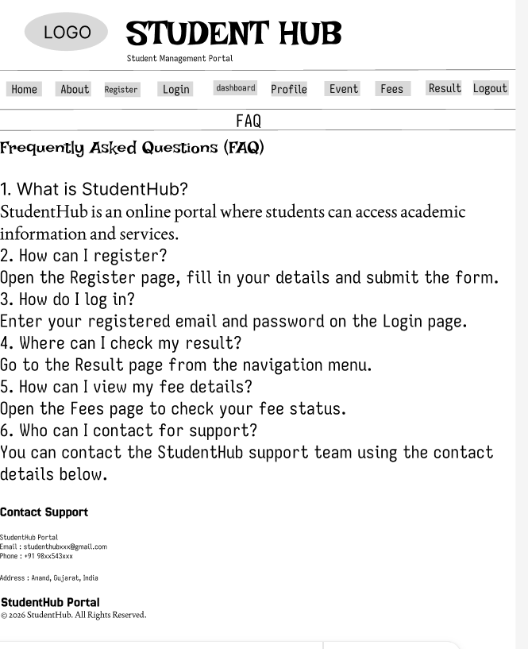

<!DOCTYPE html>
<html lang="en">

<head>
<meta charset="UTF-8">
<meta name="viewport" content="width=device-width, initial-scale=1.0">
<title>StudentHub | FAQ</title>
</head>

<body>

<header>

<table width="100%">
<tr>
<td width="15%">
<img src="studenthubLOGO.jpg" alt="StudentHub Logo" width="100">
</td>

<td>
<h1>StudentHub</h1>
<h3>Student Management Portal</h3>
</td>
</tr>
</table>

<hr>

<nav>
<a href="home.html">Home</a> |
<a href="about.html">About</a> |
<a href="register.html">Register</a> |
<a href="login.html">Login</a> |
<a href="dashboard.html">Dashboard</a> |
<a href="profile.html">Profile</a> |
<a href="event.html">Events</a> |
<a href="fees.html">Fees</a> |
<a href="result.html">Result</a> |
<a href="logout.html">Logout</a>
</nav>

<hr>

</header>

<main>

<section>

<h2>Frequently Asked Questions (FAQ)</h2>

<article>

<h3>1. What is StudentHub?</h3>

<p>
StudentHub is an online portal where students can access
academic information and services.
</p>

</article>

<hr>

<article>

<h3>2. How can I register?</h3>

<p>
Open the Register page, fill in your details and submit the form.
</p>

</article>

<hr>

<article>

<h3>3. How do I log in?</h3>

<p>
Enter your registered email and password on the Login page.
</p>

</article>

<hr>

<article>

<h3>4. Where can I check my result?</h3>

<p>
Go to the Result page from the navigation menu.
</p>

</article>

<hr>

<article>

<h3>5. How can I view my fee details?</h3>

<p>
Open the Fees page to check your fee status.
</p>

</article>

<hr>

<article>

<h3>6. Who can I contact for support?</h3>

<p>
You can contact the StudentHub support team using the contact details below.
</p>

</article>

</section>

<hr>

<section>

<h2>Contact Support</h2>

<address>
StudentHub Portal<br><br>

Email : studenthubxxx@gmail.com<br><br>

Phone : +91 98xx543xxx<br><br>

Address : Anand, Gujarat, India
</address>

</section>

</main>

<hr>

<footer>

<p><strong>StudentHub Portal</strong></p>

<p>&copy; 2026 StudentHub. All Rights Reserved.</p>

</footer>

</body>

</html>

Fees.html

WireFrame
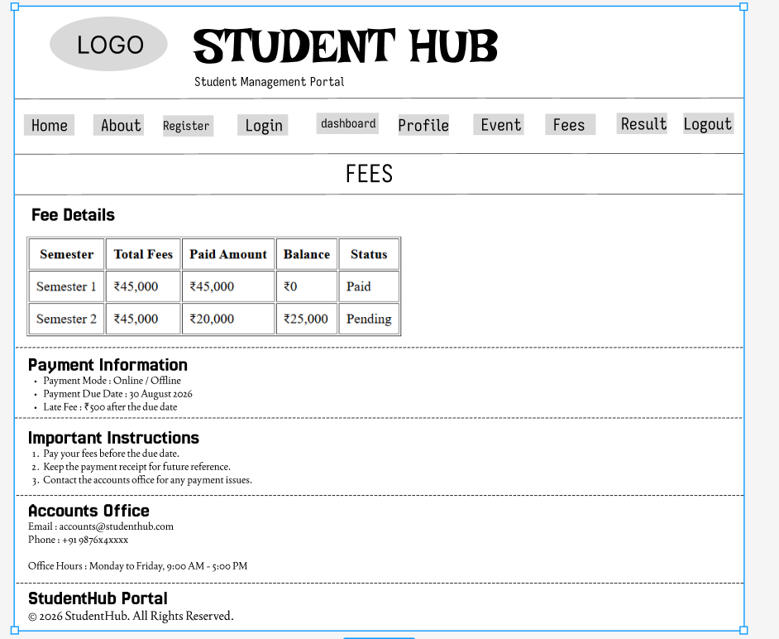

<!DOCTYPE html>
<html lang="en">

<head>
<meta charset="UTF-8">
<meta name="viewport" content="width=device-width, initial-scale=1.0">
<title>StudentHub | Fees</title>
</head>

<body>

<header>

<table width="100%">
<tr>

<td width="15%">
<img src="studenthubLOGO.jpg" alt="StudentHub Logo" width="100">
</td>

<td>
<h1>StudentHub</h1>
<h3>Student Fees</h3>
</td>

</tr>
</table>

<hr>

<nav>
<a href="home.html">Home</a> |
<a href="about.html">About</a> |
<a href="register.html">Register</a> |
<a href="login.html">Login</a> |
<a href="dashboard.html">Dashboard</a> |
<a href="profile.html">Profile</a> |
<a href="event.html">Events</a> |
<a href="fees.html">Fees</a> |
<a href="result.html">Result</a> |
<a href="logout.html">Logout</a>
</nav>

<hr>

</header>

<main>

<section>

<h2>Fee Details</h2>

<table border="1" cellpadding="8">

<tr>
<th>Semester</th>
<th>Total Fees</th>
<th>Paid Amount</th>
<th>Balance</th>
<th>Status</th>
</tr>

<tr>
<td>Semester 1</td>
<td>₹45,000</td>
<td>₹45,000</td>
<td>₹0</td>
<td>Paid</td>
</tr>

<tr>
<td>Semester 2</td>
<td>₹45,000</td>
<td>₹20,000</td>
<td>₹25,000</td>
<td>Pending</td>
</tr>

</table>

</section>

<hr>

<section>

<h2>Payment Information</h2>

<ul>

<li>Payment Mode : Online / Offline</li>

<li>Payment Due Date : 30 August 2026</li>

<li>Late Fee : ₹500 after the due date</li>

</ul>

</section>

<hr>

<section>

<h2>Important Instructions</h2>

<ol>

<li>Pay your fees before the due date.</li>

<li>Keep the payment receipt for future reference.</li>

<li>Contact the accounts office for any payment issues.</li>

</ol>

</section>

<hr>

<section>

<h2>Accounts Office</h2>

<p><strong>Email :</strong> accounts@studenthub.com</p>

<p><strong>Phone :</strong> +91 9876x4xxxx</p>

<p><strong>Office Hours :</strong> Monday to Friday, 9:00 AM - 5:00 PM</p>

</section>

</main>

<hr>

<footer>

<p><strong>StudentHub Portal</strong></p>

<p>&copy; 2026 StudentHub. All Rights Reserved.</p>

</footer>

</body>

</html>

Login.html

WireFrame
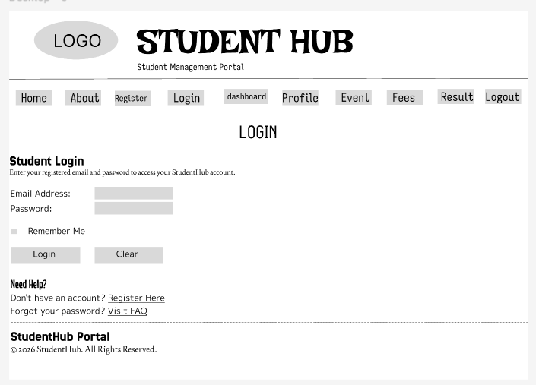

<!DOCTYPE html>
<html lang="en">

<head>
<meta charset="UTF-8">
<meta name="viewport" content="width=device-width, initial-scale=1.0">
<title>StudentHub | Login</title>
</head>

<body>

<header>

<table width="100%">
<tr>

<td width="15%">
<img src="studenthubLOGO.jpg" alt="StudentHub Logo" width="100">
</td>

<td>
<h1>StudentHub</h1>
<h3>Student Login</h3>
</td>

</tr>
</table>

<hr>

<nav>
<a href="home.html">Home</a> |
<a href="about.html">About</a> |
<a href="register.html">Register</a> |
<a href="login.html">Login</a> |
<a href="dashboard.html">Dashboard</a> |
<a href="profile.html">Profile</a> |
<a href="event.html">Events</a> |
<a href="fees.html">Fees</a> |
<a href="result.html">Result</a> |
<a href="logout.html">Logout</a>
</nav>

<hr>

</header>

<main>

<section>

<h2>Student Login</h2>

<p>
Enter your registered email and password to access your StudentHub account.
</p>

<form action="dashboard.html">

<label for="email">Email Address:</label><br>
<input type="email" id="email" name="email" required>

<br><br>

<label for="password">Password:</label><br>
<input type="password" id="password" name="password" required>

<br><br>

<input type="checkbox" id="remember">
<label for="remember">Remember Me</label>

<br><br>

<input type="submit" value="Login">
<input type="reset" value="Clear">

</form>

</section>

<hr>

<section>

<h2>Need Help?</h2>

<p>
Don't have an account?
<a href="register.html">Register Here</a>
</p>

<p>
Forgot your password?
<a href="faq.html">Visit FAQ</a>
</p>

</section>

</main>

<hr>

<footer>

<p><strong>StudentHub Portal</strong></p>

<p>Email : studenthub@gmail.com</p>

<p>&copy; 2026 StudentHub. All Rights Reserved.</p>

</footer>

</body>

</html>

Logout.html

WireFrame
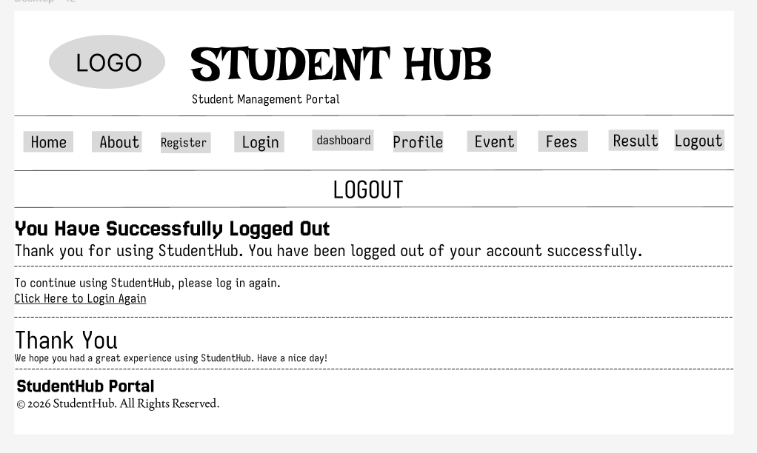

<!DOCTYPE html>
<html lang="en">

<head>
<meta charset="UTF-8">
<meta name="viewport" content="width=device-width, initial-scale=1.0">
<title>StudentHub | Logout</title>
</head>

<body>

<header>

<table width="100%">
<tr>

<td width="15%">
<img src="studenthubLOGO.jpg" alt="StudentHub Logo" width="100">
</td>

<td>
<h1>StudentHub</h1>
<h3>Logout</h3>
</td>

</tr>
</table>

<hr>

<nav>
<a href="home.html">Home</a> |
<a href="about.html">About</a> |
<a href="register.html">Register</a> |
<a href="login.html">Login</a> |
<a href="dashboard.html">Dashboard</a> |
<a href="profile.html">Profile</a> |
<a href="event.html">Events</a> |
<a href="fees.html">Fees</a> |
<a href="result.html">Result</a> |
<a href="logout.html">Logout</a>
</nav>

<hr>

</header>

<main>

<section>

<h2>You Have Successfully Logged Out</h2>

<p>
Thank you for using StudentHub.
You have been logged out of your account successfully.
</p>

<p>
To continue using StudentHub, please log in again.
</p>

<p>
<a href="login.html">Click Here to Login Again</a>
</p>

</section>

<hr>

<section>

<h2>Thank You</h2>

<p>
We hope you had a great experience using StudentHub.
Have a nice day!
</p>

</section>

</main>

<hr>

<footer>

<p><strong>StudentHub Portal</strong></p>

<p>&copy; 2026 StudentHub. All Rights Reserved.</p>

</footer>

</body>

</html>

Profile.html

WireFrame

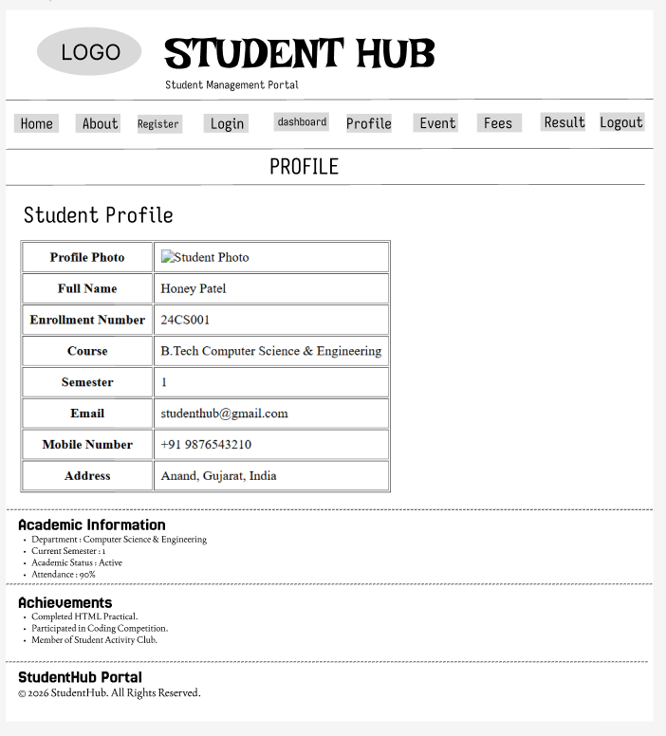

<!DOCTYPE html>
<html lang="en">

<head>
<meta charset="UTF-8">
<meta name="viewport" content="width=device-width, initial-scale=1.0">
<title>StudentHub | Profile</title>
</head>

<body>

<header>

<table width="100%">
<tr>

<td width="15%">
<img src="studenthubLOGO.jpg" alt="StudentHub Logo" width="100">
</td>

<td>
<h1>StudentHub</h1>
<h3>Student Profile</h3>
</td>

</tr>
</table>

<hr>

<nav>
<a href="home.html">Home</a> |
<a href="about.html">About</a> |
<a href="register.html">Register</a> |
<a href="login.html">Login</a> |
<a href="dashboard.html">Dashboard</a> |
<a href="profile.html">Profile</a> |
<a href="event.html">Events</a> |
<a href="fees.html">Fees</a> |
<a href="result.html">Result</a> |
<a href="logout.html">Logout</a>
</nav>
<hr>

</header>

<main>

<section>

<h2>Student Profile</h2>

<table border="1" cellpadding="8">

<tr>
<th>Profile Photo</th>
<td><img src="student.png" alt="Student Photo" width="120"></td>
</tr>

<tr>
<th>Full Name</th>
<td>Honey Patel</td>
</tr>

<tr>
<th>Enrollment Number</th>
<td>24CS001</td>
</tr>

<tr>
<th>Course</th>
<td>B.Tech Computer Science & Engineering</td>
</tr>

<tr>
<th>Semester</th>
<td>1</td>
</tr>

<tr>
<th>Email</th>
<td>studenthub@gmail.com</td>
</tr>

<tr>
<th>Mobile Number</th>
<td>+91 9876543210</td>
</tr>

<tr>
<th>Address</th>
<td>Anand, Gujarat, India</td>
</tr>

</table>

</section>

<hr>

<section>

<h2>Academic Information</h2>

<ul>

<li>Department : Computer Science & Engineering</li>

<li>Current Semester : 1</li>

<li>Academic Status : Active</li>

<li>Attendance : 90%</li>

</ul>

</section>

<hr>

<section>

<h2>Achievements</h2>

<ul>

<li>Completed HTML Practical.</li>

<li>Participated in Coding Competition.</li>

<li>Member of Student Activity Club.</li>

</ul>

</section>

</main>

<hr>

<footer>

<p><strong>StudentHub Portal</strong></p>

<p>&copy; 2026 StudentHub. All Rights Reserved.</p>

</footer>

</body>

</html>

Register.html

WireFrame
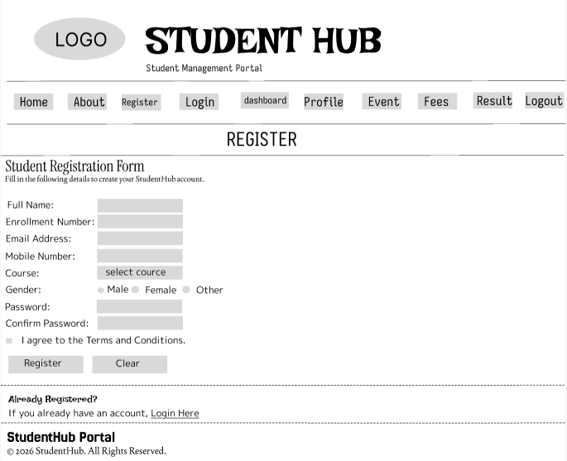

<!DOCTYPE html>
<html lang="en">

<head>
<meta charset="UTF-8">
<meta name="viewport" content="width=device-width, initial-scale=1.0">
<title>StudentHub | Register</title>
</head>

<body>

<header>

<table width="100%">
<tr>

<td width="15%">
<img src="studenthubLOGO.jpg" alt="StudentHub Logo" width="100">
</td>

<td>
<h1>StudentHub</h1>
<h3>Student Registration</h3>
</td>

</tr>
</table>

<hr>

<nav>
<a href="home.html">Home</a> |
<a href="about.html">About</a> |
<a href="register.html">Register</a> |
<a href="login.html">Login</a> |
<a href="dashboard.html">Dashboard</a> |
<a href="profile.html">Profile</a> |
<a href="event.html">Events</a> |
<a href="fees.html">Fees</a> |
<a href="result.html">Result</a> |
<a href="logout.html">Logout</a>
</nav>

<hr>

</header>

<main>

<section>

<h2>Student Registration Form</h2>

<p>
Fill in the following details to create your StudentHub account.
</p>

<form action="login.html">

<label for="name">Full Name:</label><br>
<input type="text" id="name" name="name" required>

<br><br>

<label for="enrollment">Enrollment Number:</label><br>
<input type="text" id="enrollment" name="enrollment" required>

<br><br>

<label for="email">Email Address:</label><br>
<input type="email" id="email" name="email" required>

<br><br>

<label for="mobile">Mobile Number:</label><br>
<input type="tel" id="mobile" name="mobile">

<br><br>

<label for="course">Course:</label><br>

<select id="course" name="course">

<option>Select Course</option>
<option>B.Tech CSE</option>
<option>B.Tech IT</option>
<option>BCA</option>
<option>MCA</option>

</select>

<br><br>

<label>Gender:</label><br>

<input type="radio" id="male" name="gender">
<label for="male">Male</label>

<input type="radio" id="female" name="gender">
<label for="female">Female</label>

<input type="radio" id="other" name="gender">
<label for="other">Other</label>

<br><br>

<label for="password">Password:</label><br>
<input type="password" id="password" name="password" required>

<br><br>

<label for="confirm">Confirm Password:</label><br>
<input type="password" id="confirm" name="confirm" required>

<br><br>

<input type="checkbox" id="terms" required>
<label for="terms">I agree to the Terms and Conditions.</label>

<br><br>

<input type="submit" value="Register">
<input type="reset" value="Clear">

</form>

</section>

<hr>

<section>

<h2>Already Registered?</h2>

<p>
If you already have an account,
<a href="login.html">Login Here</a>
</p>

</section>

</main>

<hr>

<footer>

<p><strong>StudentHub Portal</strong></p>

<p>&copy; 2026 StudentHub. All Rights Reserved.</p>

</footer>

</body>

</html>

Result.html

WireFrame
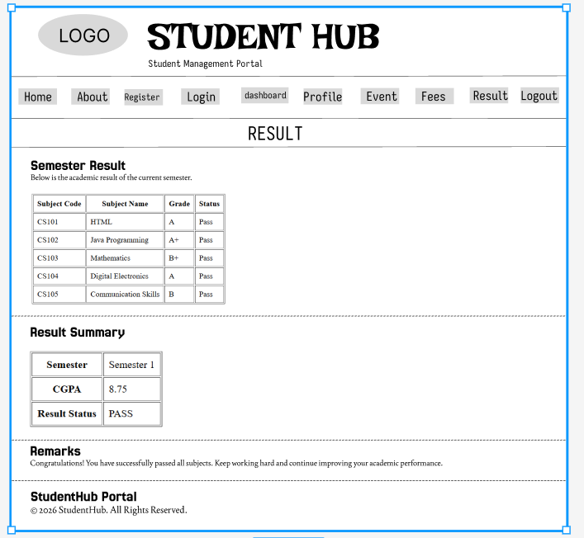

<!DOCTYPE html>
<html lang="en">

<head>
<meta charset="UTF-8">
<meta name="viewport" content="width=device-width, initial-scale=1.0">
<title>StudentHub | Result</title>
</head>

<body>

<header>

<table width="100%">
<tr>

<td width="15%">
<img src="studenthubLOGO.jpg" alt="StudentHub Logo" width="100">
</td>

<td>
<h1>StudentHub</h1>
<h3>Student Result</h3>
</td>

</tr>
</table>

<hr>

<nav>
<a href="home.html">Home</a> |
<a href="about.html">About</a> |
<a href="register.html">Register</a> |
<a href="login.html">Login</a> |
<a href="dashboard.html">Dashboard</a> |
<a href="profile.html">Profile</a> |
<a href="event.html">Events</a> |
<a href="fees.html">Fees</a> |
<a href="result.html">Result</a> |
<a href="logout.html">Logout</a>
</nav>

<hr>

</header>

<main>

<section>

<h2>Semester Result</h2>

<p>
Below is the academic result of the current semester.
</p>

<table border="1" cellpadding="8">

<tr>
<th>Subject Code</th>
<th>Subject Name</th>
<th>Grade</th>
<th>Status</th>
</tr>

<tr>
<td>CS101</td>
<td>HTML</td>
<td>A</td>
<td>Pass</td>
</tr>

<tr>
<td>CS102</td>
<td>Java Programming</td>
<td>A+</td>
<td>Pass</td>
</tr>

<tr>
<td>CS103</td>
<td>Mathematics</td>
<td>B+</td>
<td>Pass</td>
</tr>

<tr>
<td>CS104</td>
<td>Digital Electronics</td>
<td>A</td>
<td>Pass</td>
</tr>

<tr>
<td>CS105</td>
<td>Communication Skills</td>
<td>B</td>
<td>Pass</td>
</tr>

</table>

</section>

<hr>

<section>

<h2>Result Summary</h2>

<table border="1" cellpadding="8">

<tr>
<th>Semester</th>
<td>Semester 1</td>
</tr>

<tr>
<th>CGPA</th>
<td>8.75</td>
</tr>

<tr>
<th>Result Status</th>
<td>PASS</td>
</tr>

</table>

</section>

<hr>

<section>

<h2>Remarks</h2>

<p>
Congratulations! You have successfully passed all subjects.
Keep working hard and continue improving your academic performance.
</p>

</section>

</main>

<hr>

<footer>

<p><strong>StudentHub Portal</strong></p>

<p>&copy; 2026 StudentHub. All Rights Reserved.</p>

</footer>

</body>

</html>

Screenshot :

Output :

Home.html

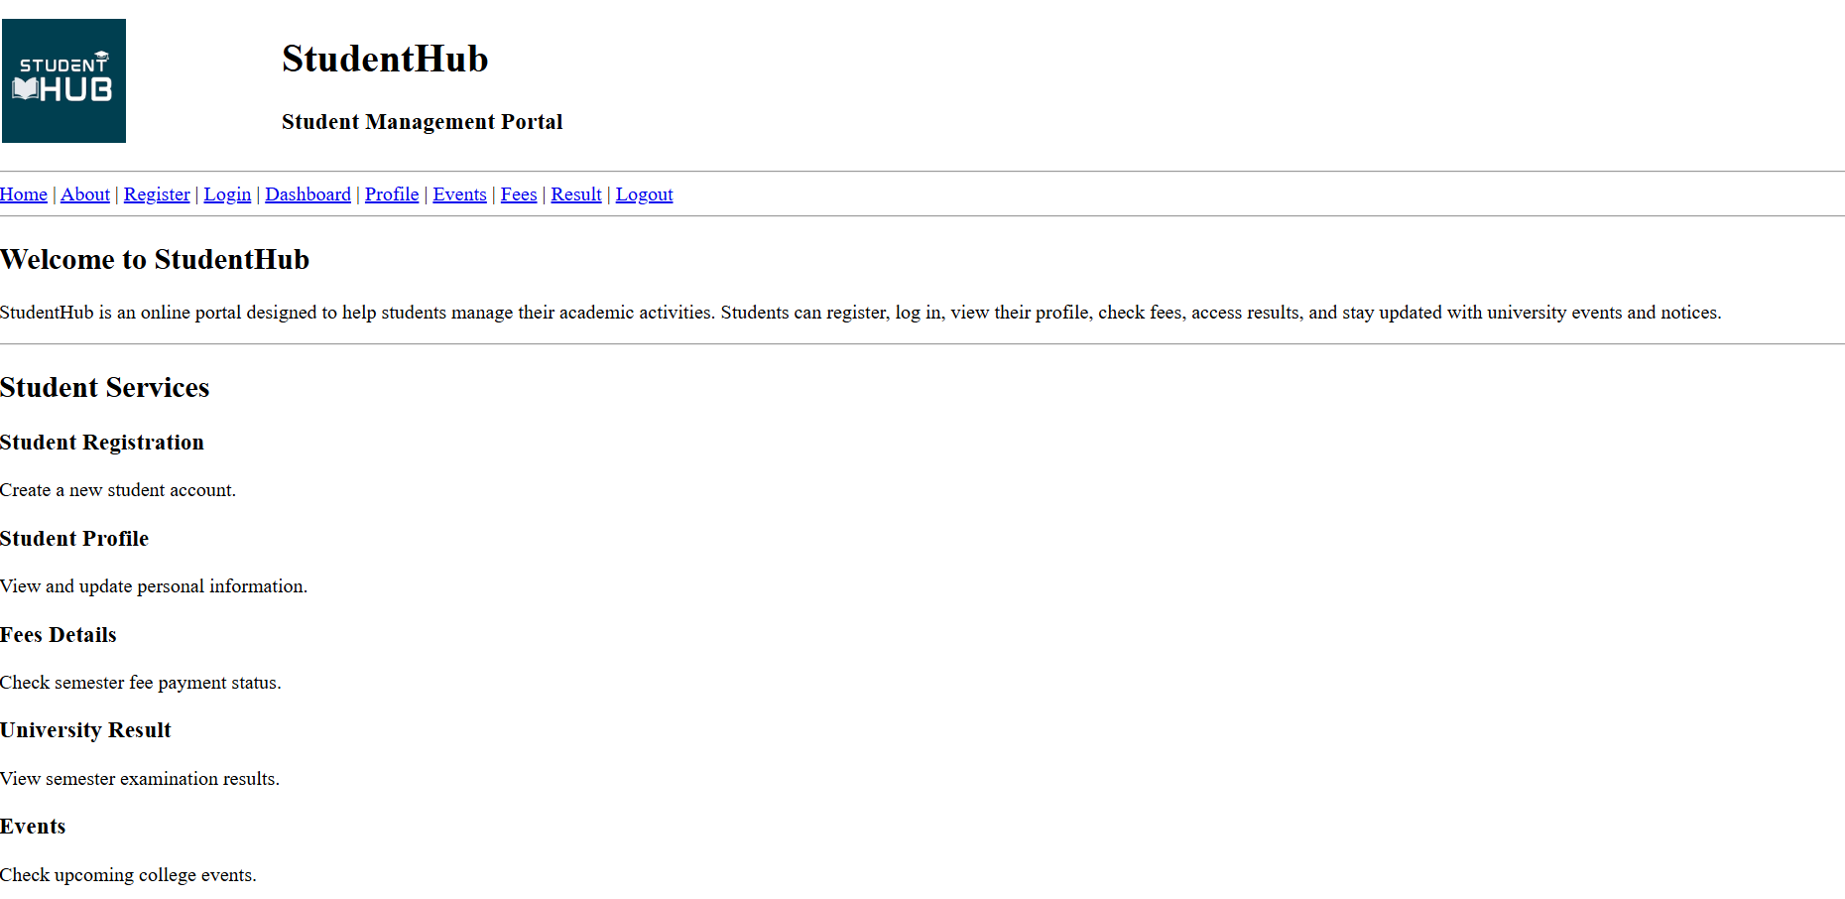
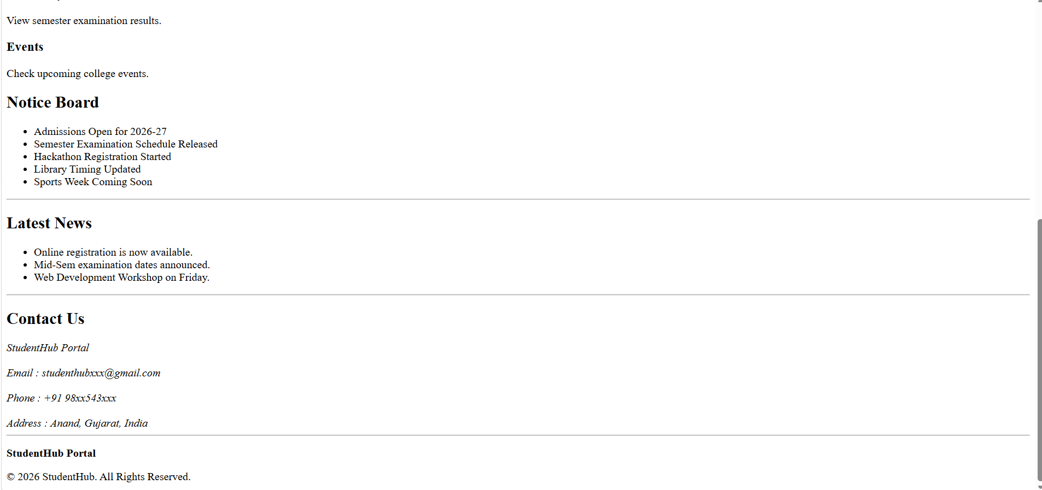

About.html

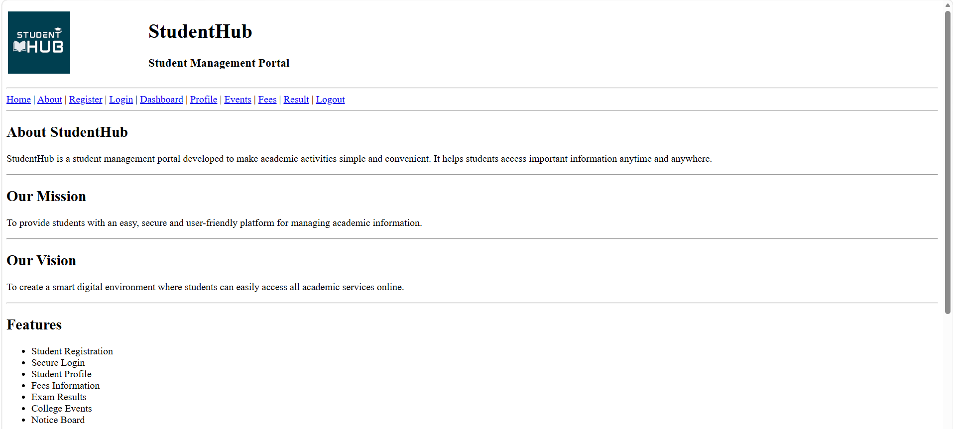
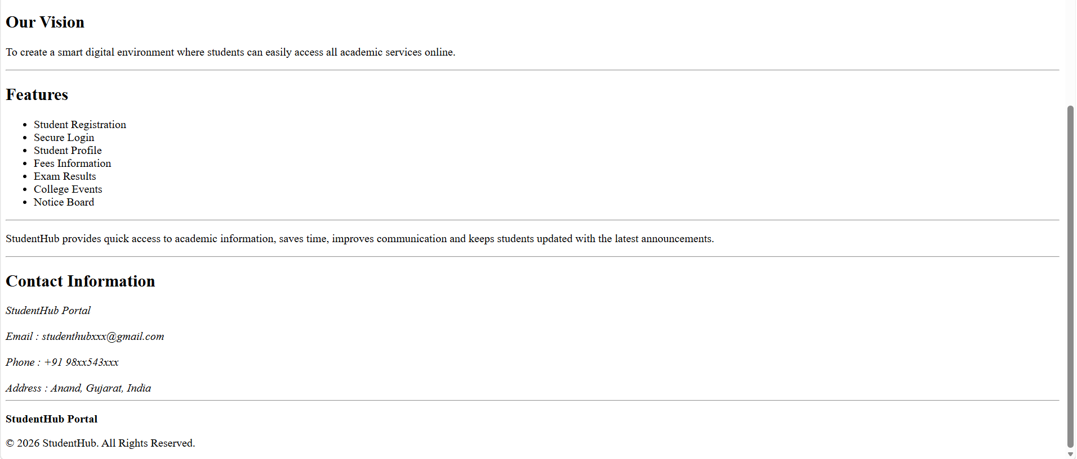

Dashboard.html

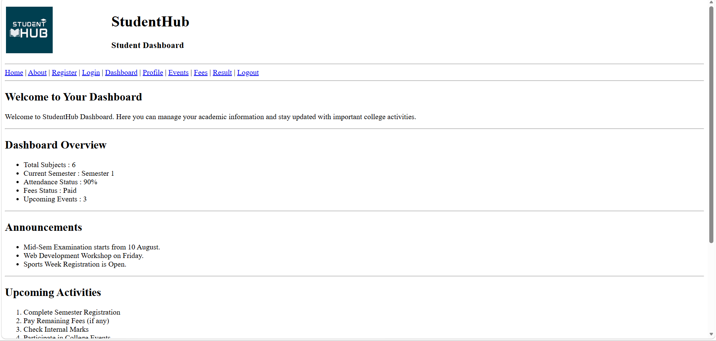
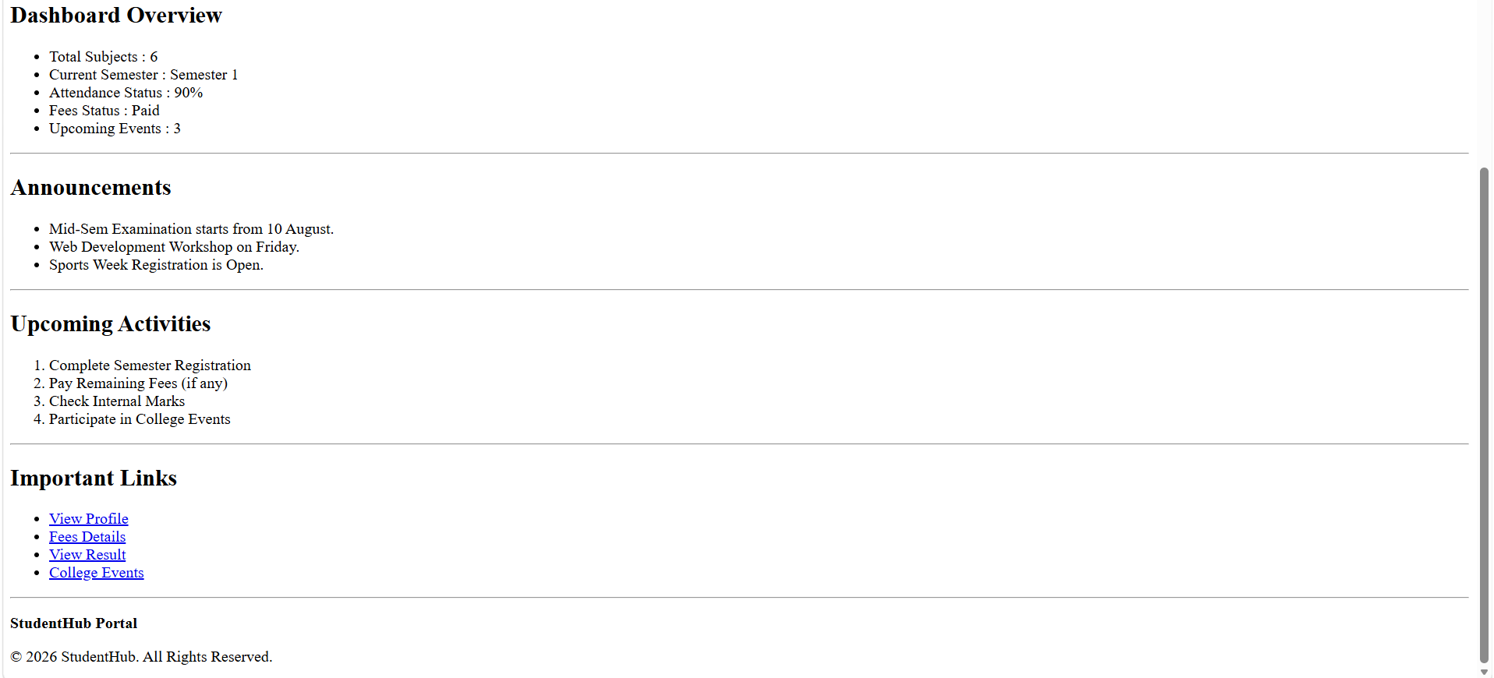
Even.html
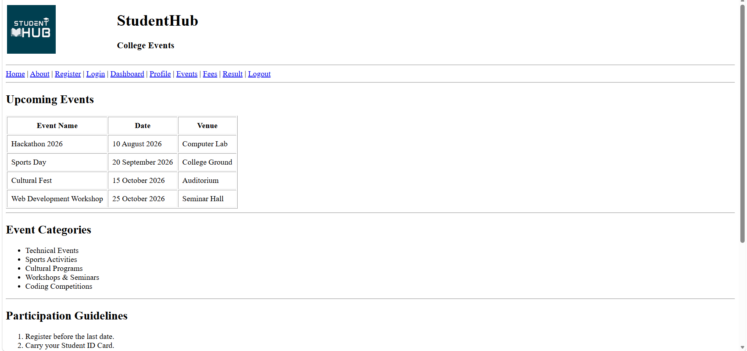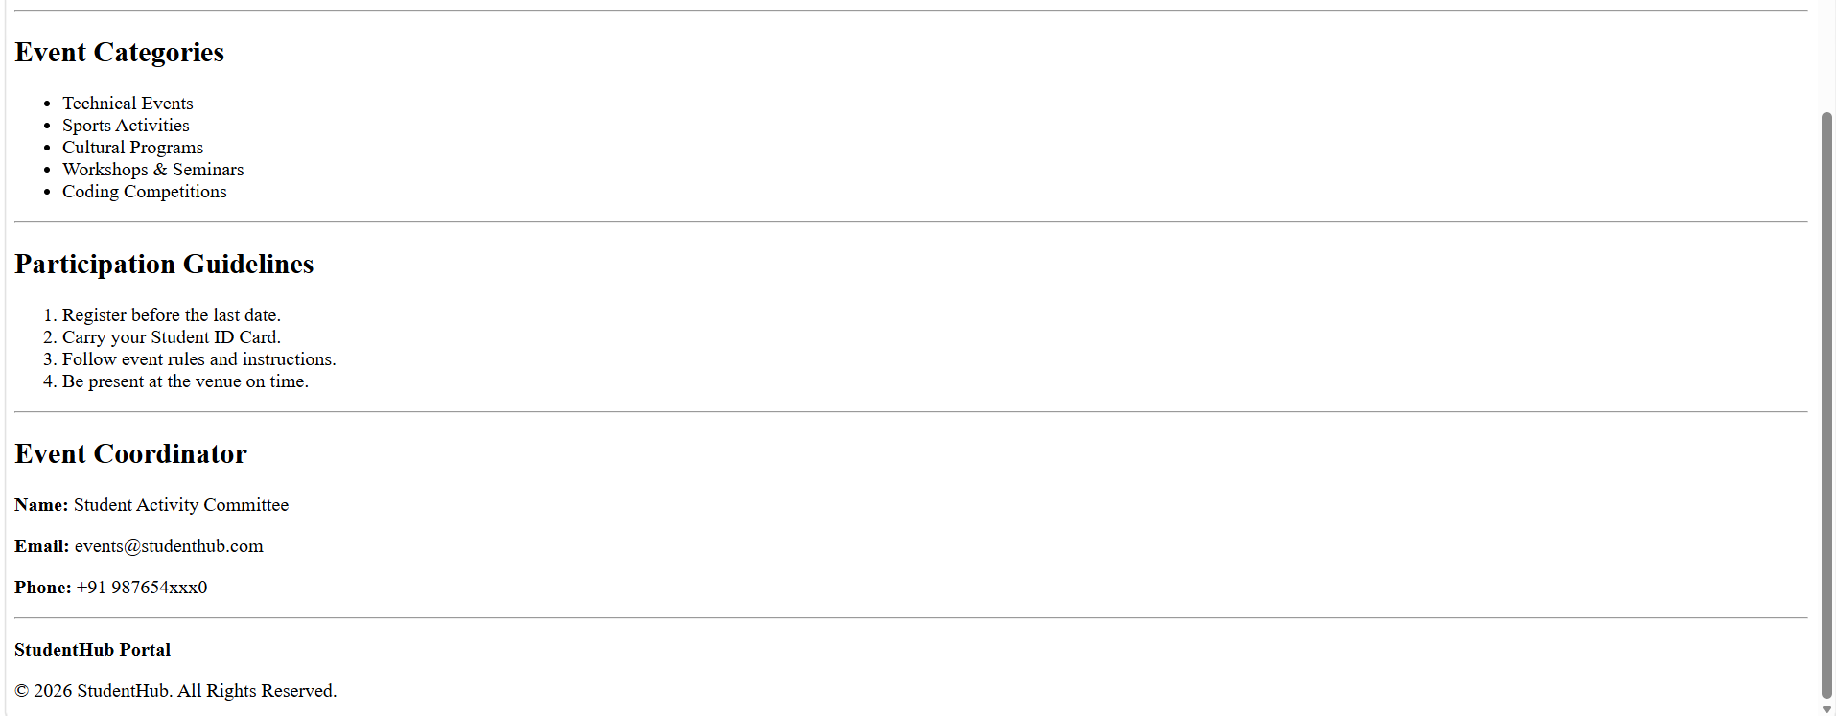

FAQ.html
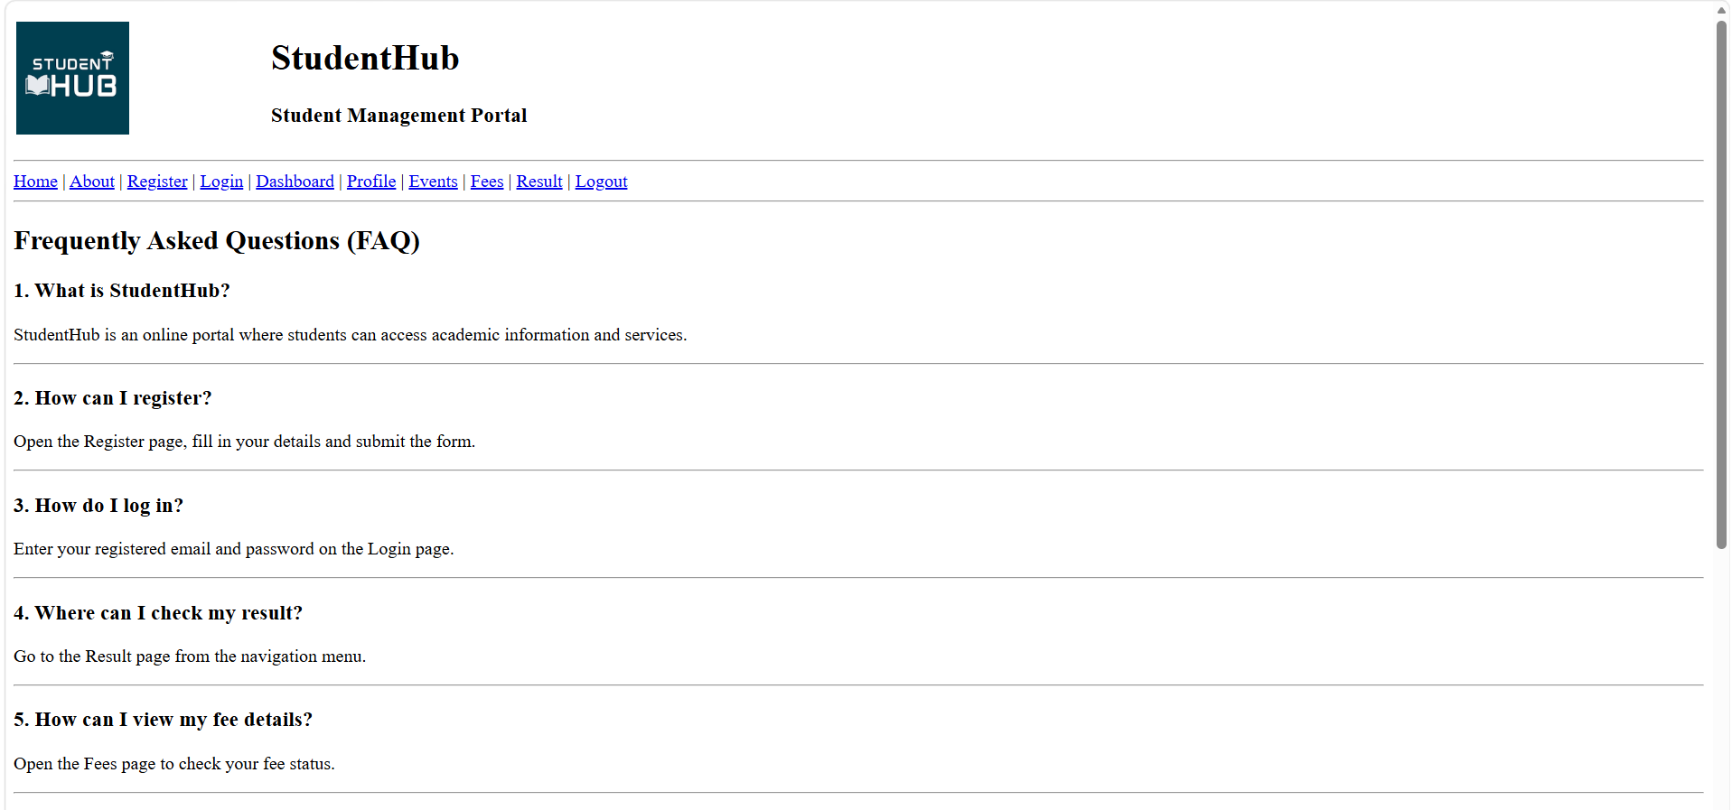
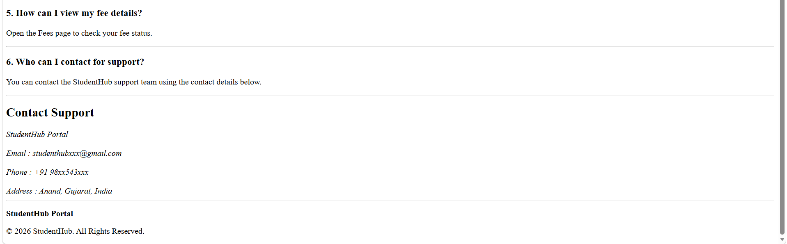

FEES.html

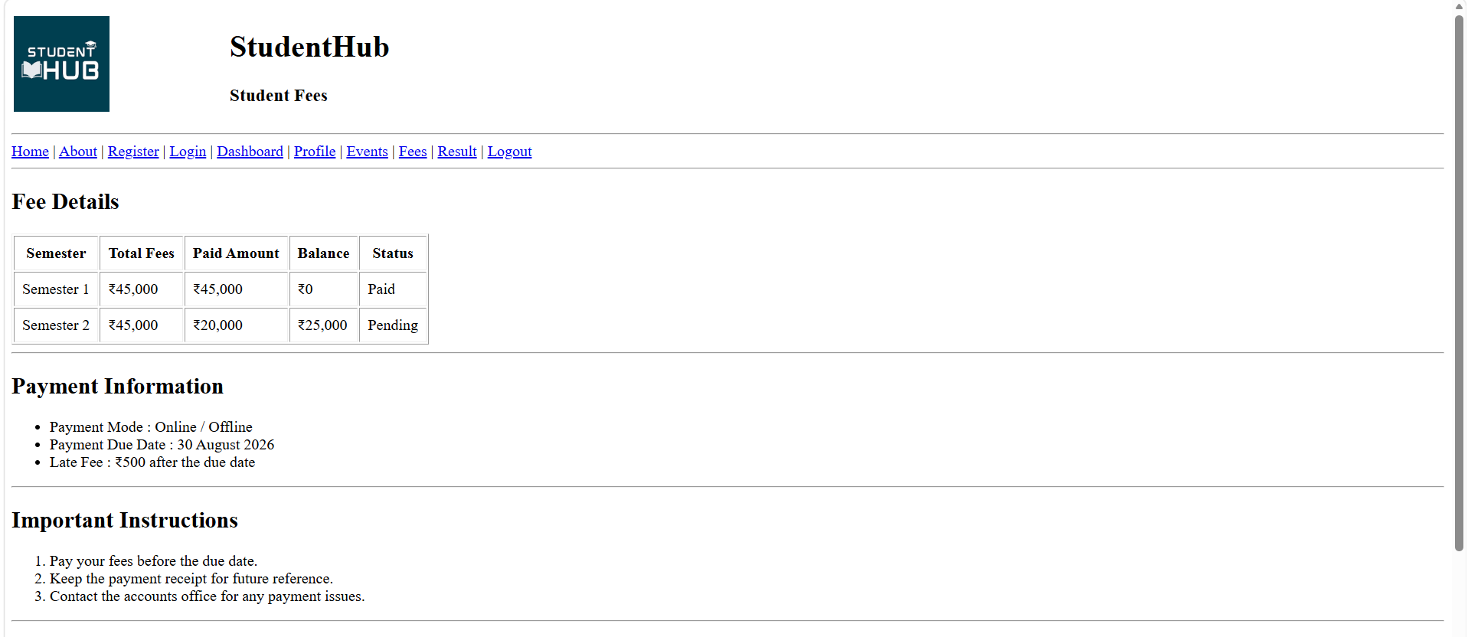
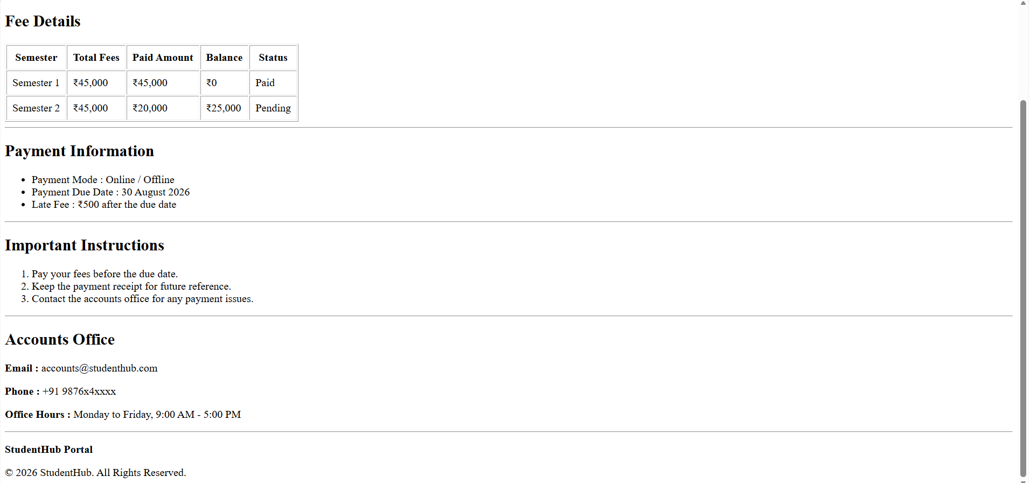

Home.html

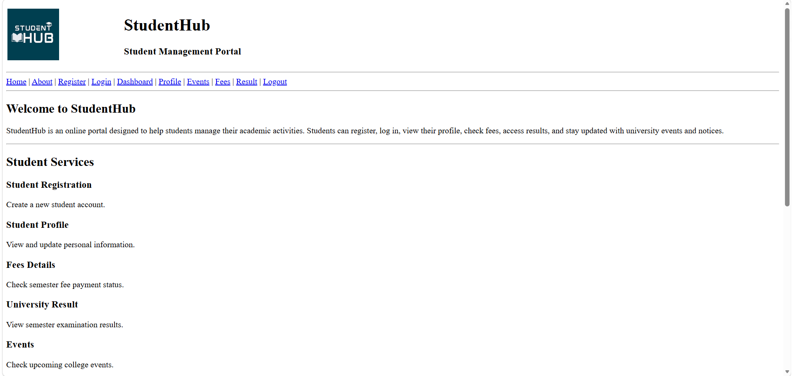
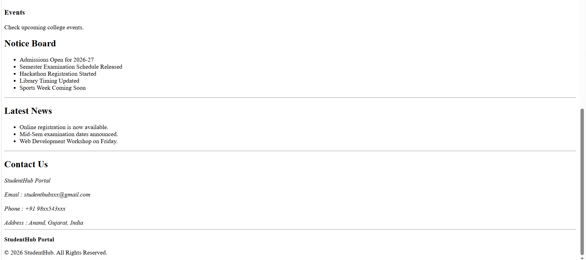

Login.html

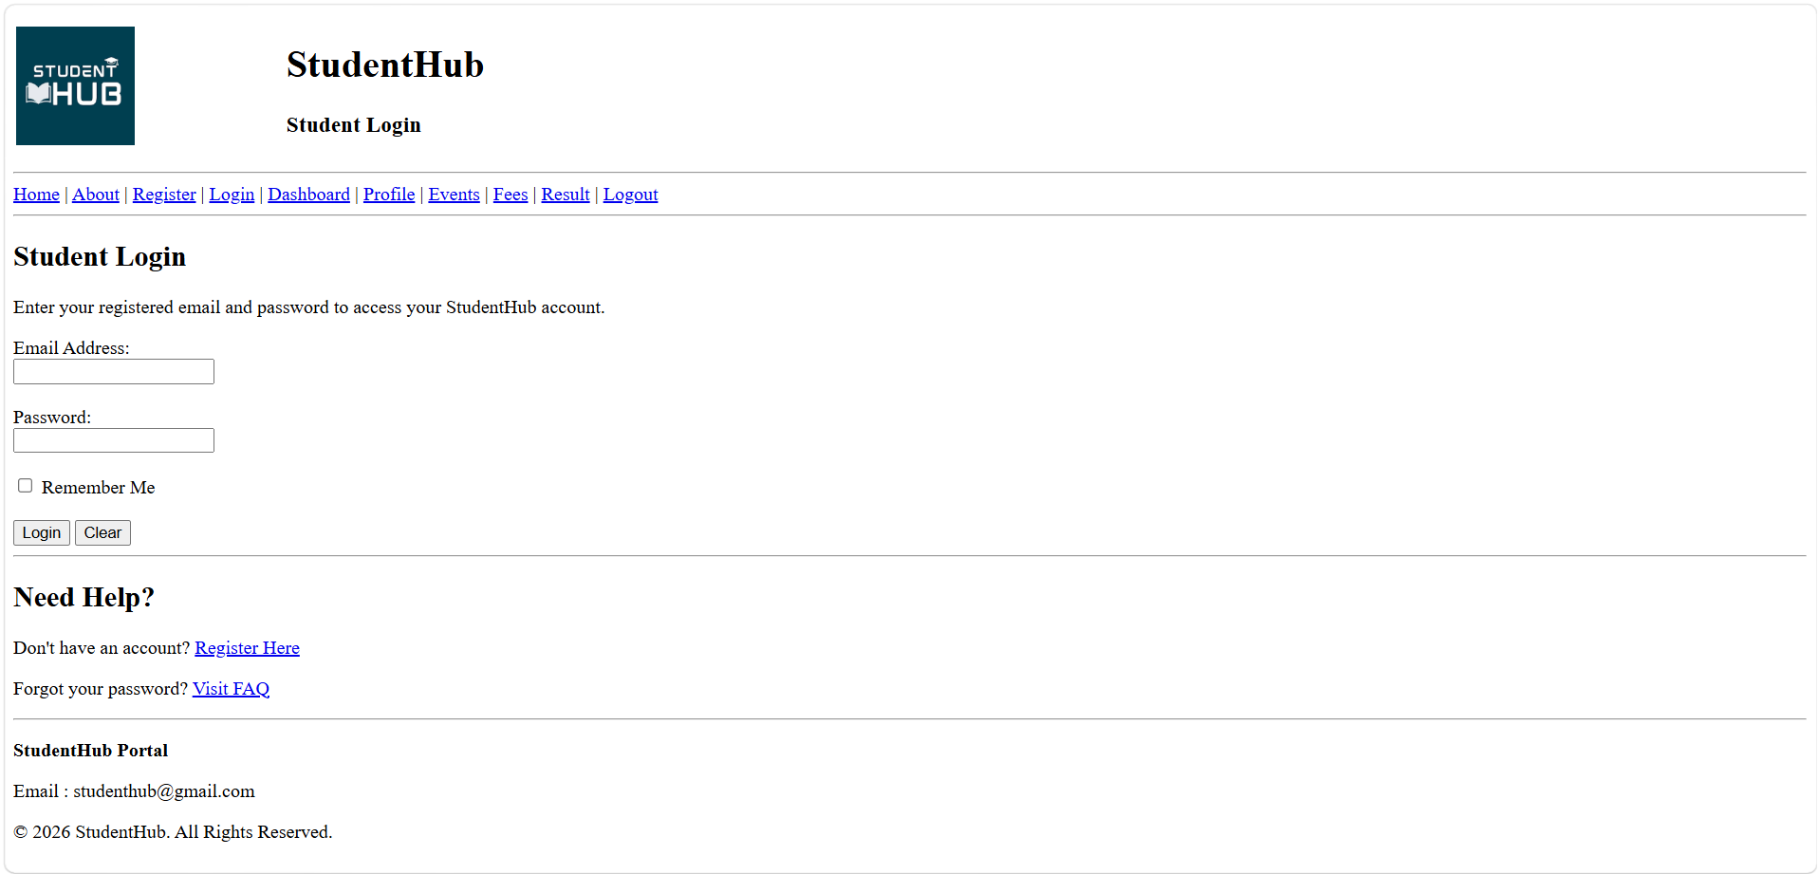

LOGOUT.html

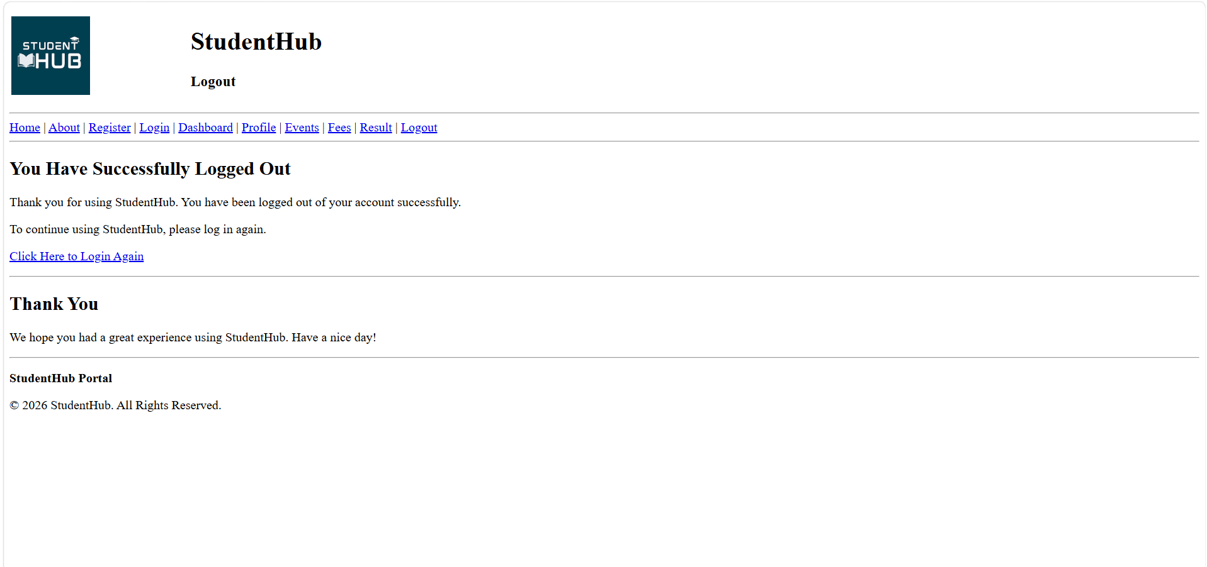
Profile.html

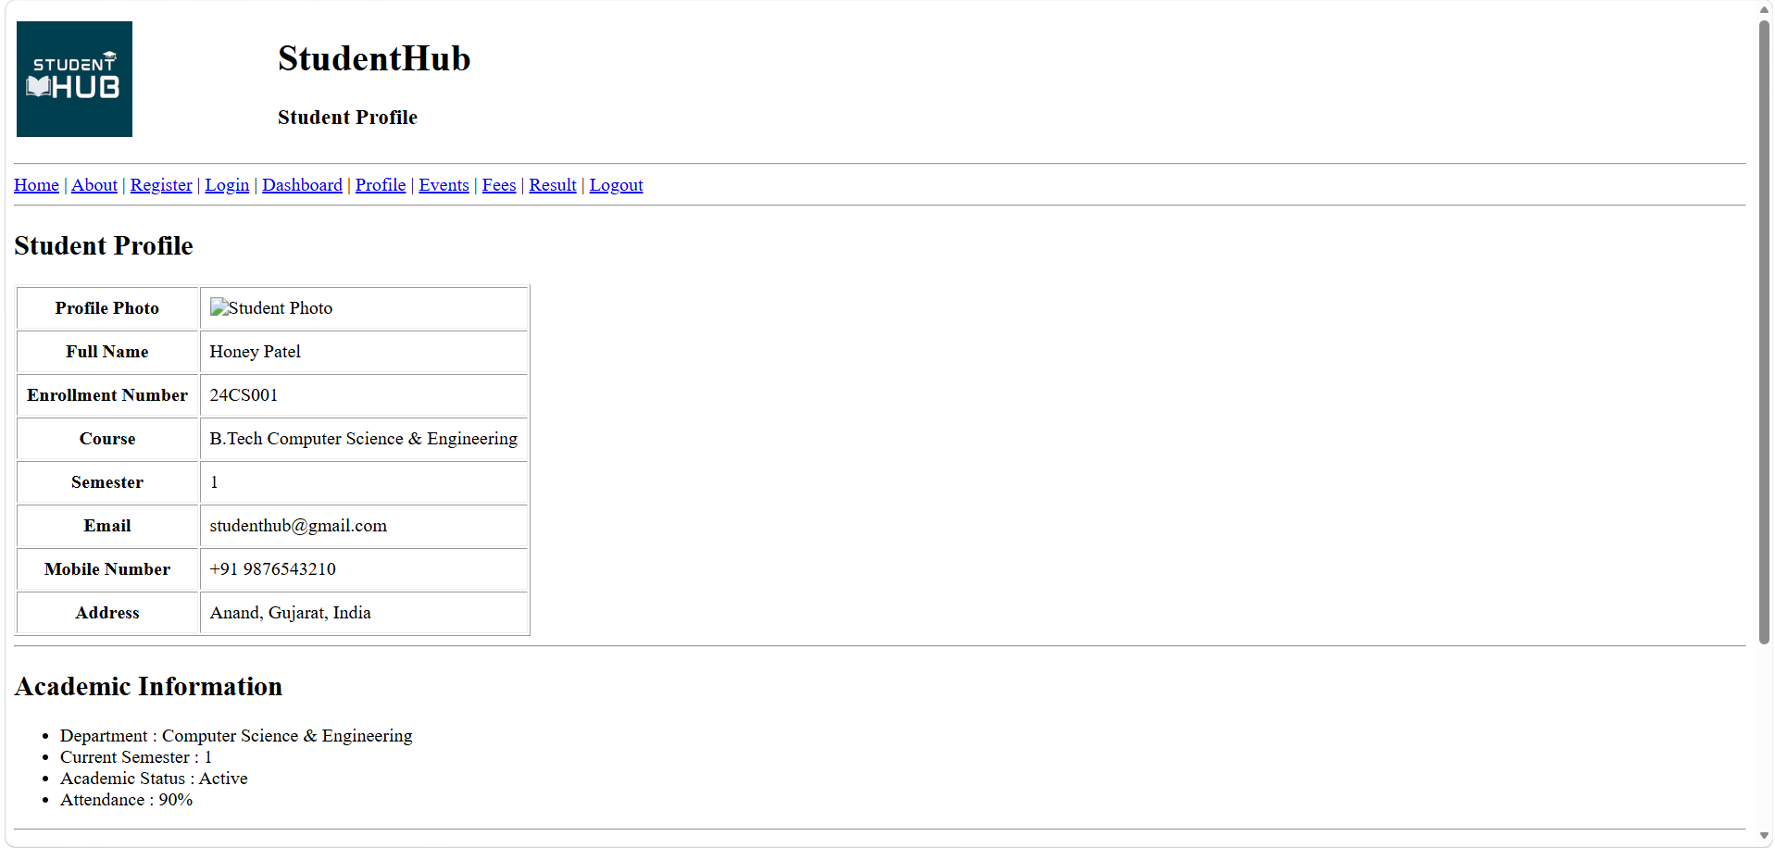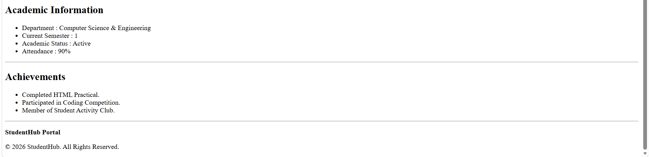

Registration.html

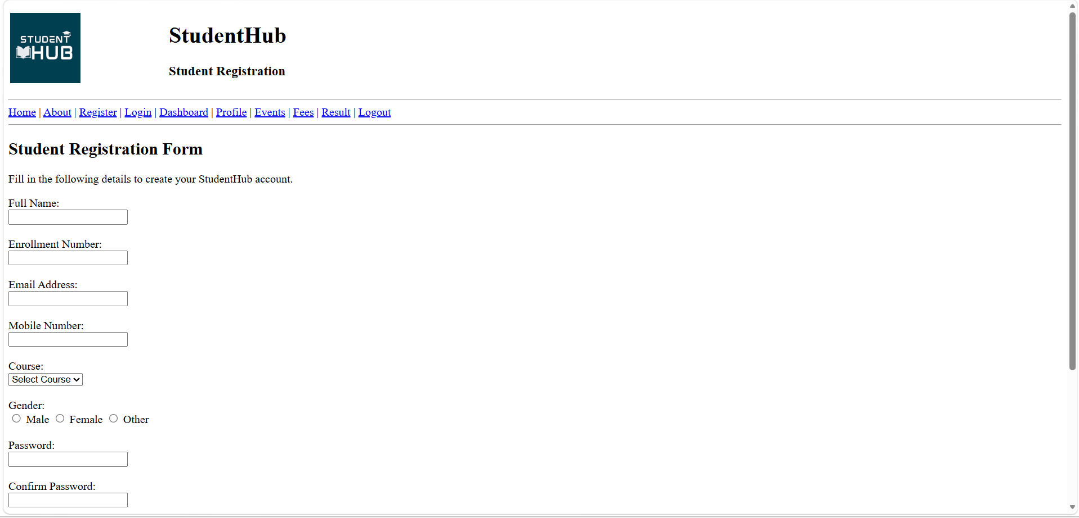
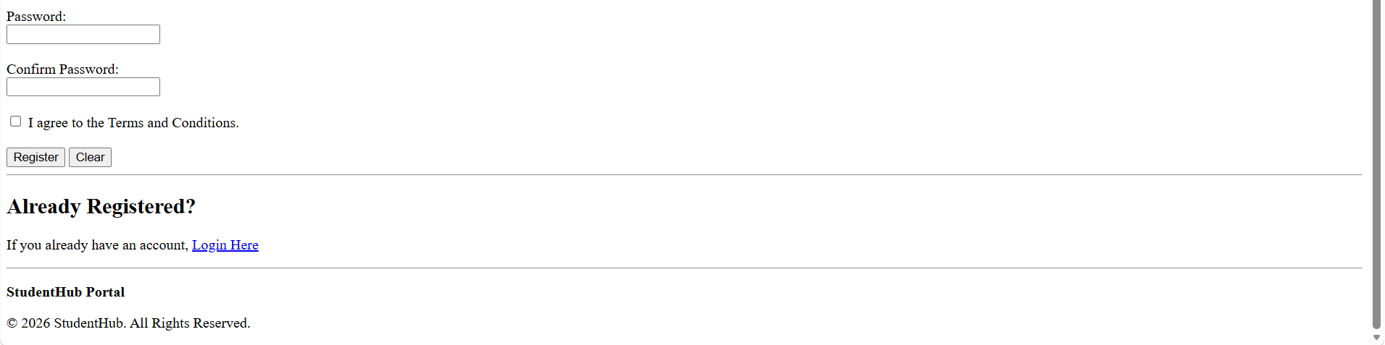
Result.html

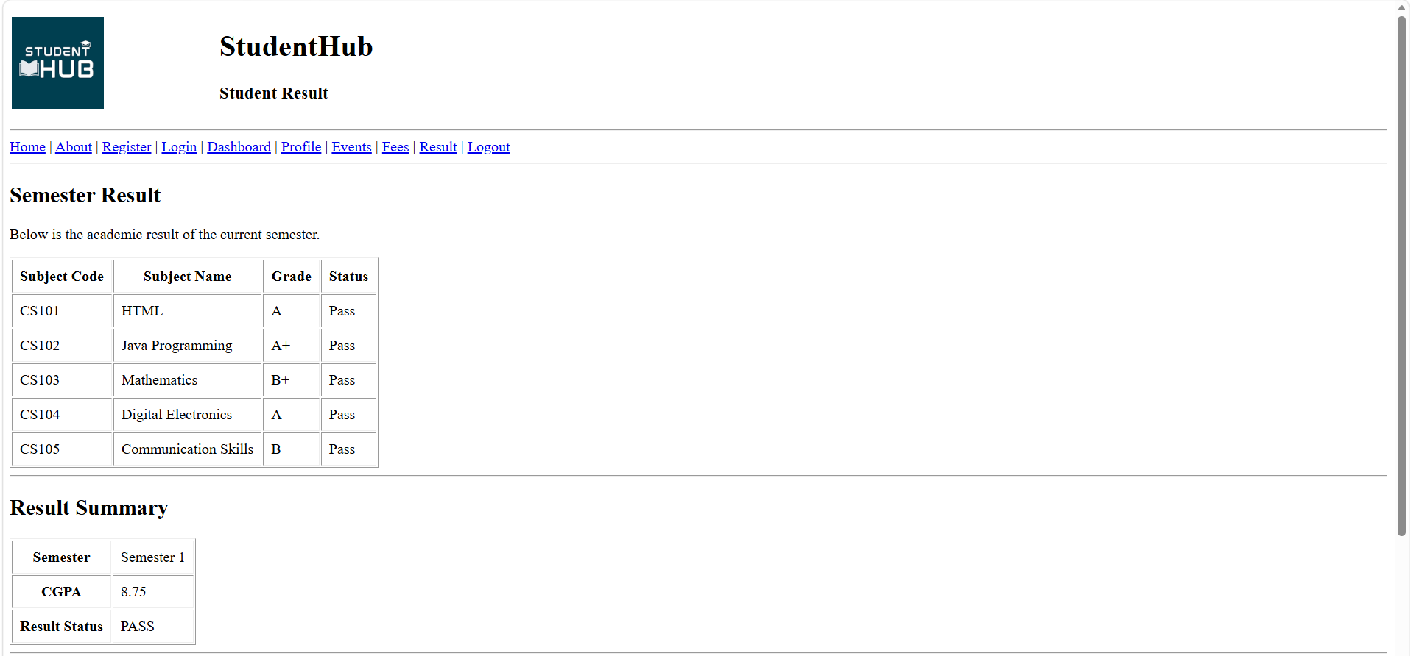
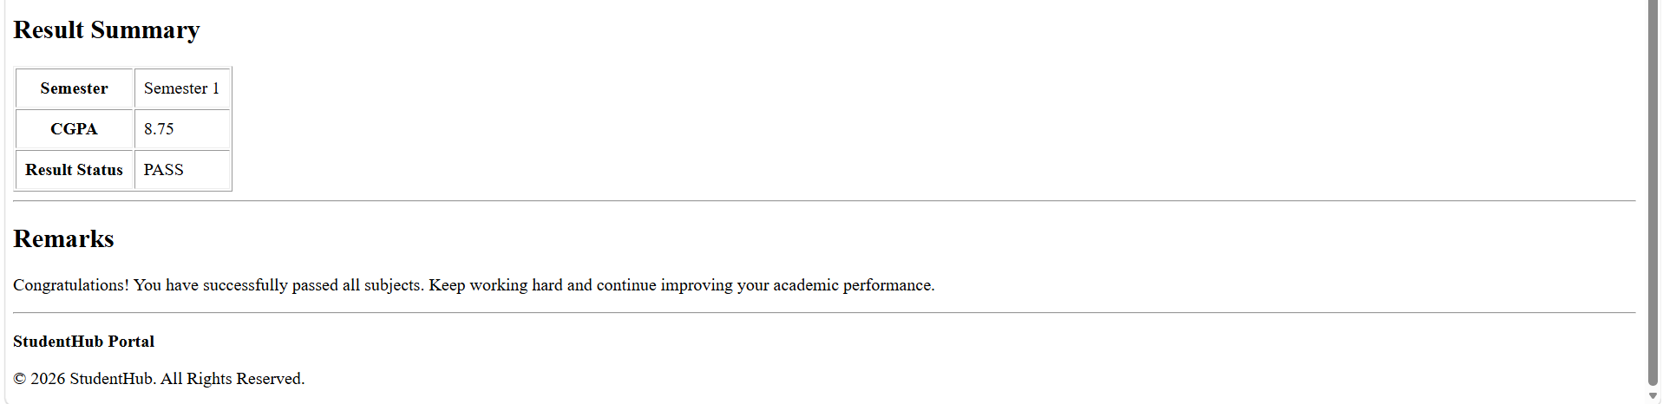

Learning outcome :

- Learned how to create a wireframe for a website.
- Understood the importance of wireframes in website planning.
- Learned how to design a sitemap for proper website navigation.
- Understood the structure and flow of a website.
- Improved website planning and design skills.

• Learned to create a responsive website using HTML, CSS, and JavaScript.
• Improved web page design and layout skills.
• Learned how to connect multiple web pages using hyperlinks.
• Understood the use of forms, navigation bar, and different HTML elements.
• Improved problem-solving and debugging skills during project development.
• Learned to use GitHub for uploading and managing project files.
• Gained experience in teamwork and project management.

Repositry Link:

https://github.com/HONEY2218/STUDENTHUB

